Installation:

<http://docs.h2o.ai/driverless-ai/latest-stable/docs/userguide/install/windows.html>

Ubuntu WSL installation:

<https://docs.microsoft.com/en-us/windows/wsl/faq#what-is-windows-subsystem-for-linux-wsl>

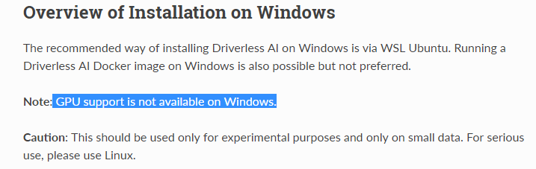

Account:

Ubuntu login: ziweifan177/Fzw1985!!!!

Installation:

Step1: download Deb version of driverless:

Step2: download WSL Linux 18

Step3: Enable Windows Subsystem for Linux and restart laptop

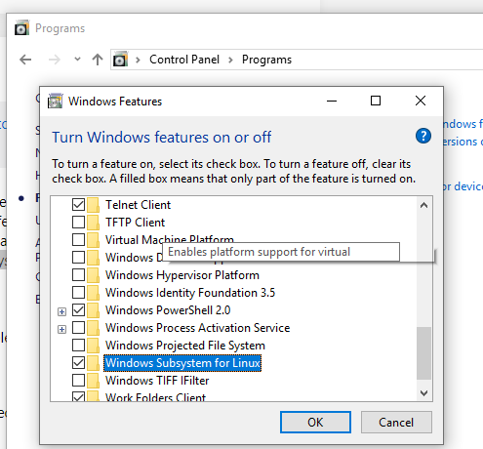

Step4: Click Ubuntu icon for auto installing:

Step5: windows cmd and bash.exe for running Ubuntu:

(lsb_release –a: check the info of current Ubuntu version.)

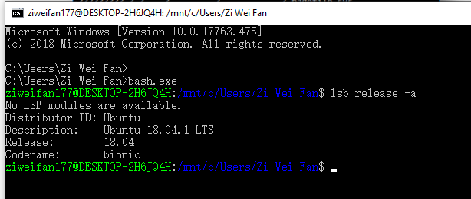

Step6: Direct to different path by:

(/mnt/c is the mount points)



Step7: Install Driverless AI in the corresponding path.

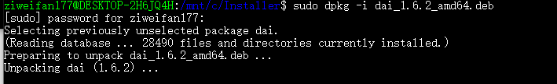

Step8: Run H2O

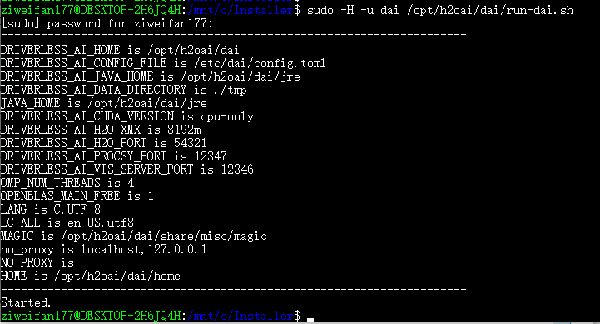

Step9: Run by localhost:

Type 127.0.0.1:12345 (default)

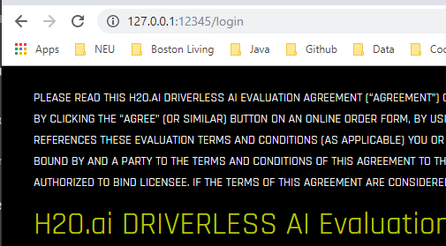

Step10: Input the license code:

